Colosseum Dental Gender Pay Report 2020/21

Commitment
Operating a fair pay structure, Colosseum Dental is committed to the principle of equal opportunities and equal treatment for all colleagues, in accordance with the Equality Act 2010.
In all that we do, we strive to demonstrate that we care more about our people, recognising that our people are our greatest asset. We want to ensure our workforce is diverse and inclusive. We aim to recruit and retain talent by allowing all of our people the same opportunities to grow and develop whilst rewarding them for their contributions. We are confident that our HR processes and practices ensure that our people are not paid differently due to their gender.

2020/21 Gender Pay Gap
Most of our colleagues work in one of our modern dental practices across the United Kingdom. More than 92% of our workforce is female.
The gender pay gap at practice level is neglible (if at all present) across roles as demonstrated in the table below.
Our support hub includes our most senior appointed roles within the organisation. While our dominant gender within the organisation is female, there is a greater balance across supporting roles and functions than among practice-level teams.
Roles within the support hub attract a higher pay rate, with male appointments holding the majority of the executive and senior leadership roles in 2020.
Females make up 88% of our workforce in higher-paid roles within the organisation, with 3% of our male workforce holding the highest executive positions.

Equality and Fairness
We are proud that males and females, in similar or like for like roles within our practice teams, are paid equally.
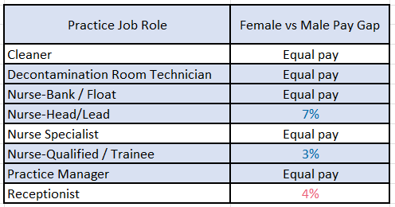
Values <1% margin have been referenced under ‘Equal Pay’

Females are the largest group of employees in all quartiles of pay. The mean (average) gender pay gap at 65% for 2020/21 is solely subject to the predominantly male appointments in our executive team.
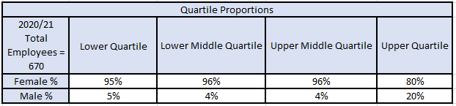
The high median (mid-point) pay gap at 33% reflects a substantial volume of female leavers, embarking on new experiences, or retiring, who were situated in the upper quartiles. Due to the COVID-19 pandemic, the decision was made not to replace the positions at that time.
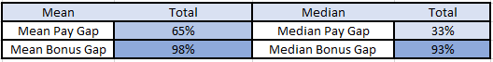
In the 12 months to April 2021, 10% of females and 20% of males received a bonus. Our 98% mean bonus gap is subject to the executive and senior roles within the business, who were male.

Outlook
We are committed to developing our internal talent through robust acceleration programmes, which we hope will continue to promote progression and provide career opportunities for female employees into senior roles.

I hereby confirm that Colosseum Dental UK is committed to the principle of gender pay equality and that this information and data reported are accurate as of the snapshot date of 5th April 2021.

Fiona Godfrey
HR Operations Manager
Colosseum Dental UK

Disclaimer: Please be advised that, unfortunately, inaccurate data was collated/reported on for 2018/19 and 2019/20’s gender pay gap reports. Having identified this, we have now rectified our data collation methods. Thus, the above report provides insight into 2020/21’s gender pay gap, factors that impacted the statistics, and what measures we shall endeavour to take to close the gap moving forwards.

